# Multiple Quests using the ScriptEase II Story System

In this tutorial we will be adding another pirate to our game. This pirate will wander around the world looking for his parrot and refuse to come on board before finding it. We will have to find his parrot and tell it to go back to the pirate.

This isn’t really related to our main story of speaking with the Captain, so we will need to make another quest for it.

## Getting Started:

1. Back up your game files.
2. Make sure ScriptEase II is closed and then start Aurora.
3. Open the Treasure Island area. Create a creature using Edit Copy from “NPCS” 🡪 “Humans” 🡪 “Shop Keeper” NPC called “Samwell” with the tag “samwell”. Make sure the faction is set to “Defender” in the Advanced tab.
4. Place the pirate to the left of the cave and under the forest in the Treasure Island area as in the screenshot below.

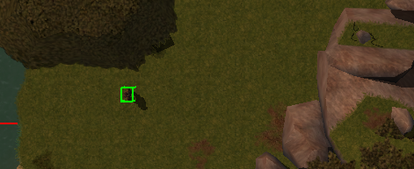

1. Create a parrot using Edit Copy from “Monsters” 🡪 “Animals” 🡪 “Birds” 🡪 “Parrot” and name it “Captain Flint” with the tag “captain_flint”. Place it on the other side of the cave.

## Walking Paths with Waypoints:

1. The pirate is searching for his parrot, so it would make sense for him to walk around a bit. We can do this easily without scripts by creating waypoints with specific names. Create four new waypoints with the names and tags “WP_samwell_01” through “WP_samwell_04”.
2. Place them around Samwell like in the screenshot below.

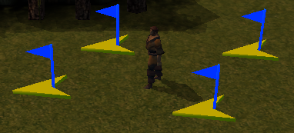

Order does not matter for our purposes. Naming our waypoints this way makes a creature walk from the first one to the next, and then the other way.

1. Do the same for the parrot with four more waypoints named and tagged with “WP_captain_flint_xx”, where xx are numbers 01 to 04. Place the four waypoints around the parrot.
2. No scripting is needed. Samwell and Captain Flint will find the waypoints automatically and start walking. Save and test that the two creatures are walking their respective waypoints.
3. Add one more waypoint to the game. This will be where the pirate and the parrot run to once they are reunited. Since this will need actual scripting, we won’t name it like the others. Instead, name it “Ship Location” and tag it “ship_location”. Place it on the pirate ship, near the player start location.

## Adding More Conversations:

1. Let’s add some more conversations to the game. Right now, we’re only speaking with the Captain. However, these two creatures will require some text as well. Find the Samwell blueprint from the Creature palette on the right (not the Samwell shown on the map), right-click, Edit, and click on the “Edit” button below Conversation. The “Conversation Editor” will open up.
2. Add a conversation node with the text “Oi there, have ye seen me parrot?”
3. Add a player response with the text “Aye!”
4. Add a response to this that says, “Well, tell ‘im ter come o’er here!”
5. Add another player response to the first node (“Oi there,…”) with text “Nay.”
6. Add a response to this that says, “If ye see one, tell ‘im ter come o’er here!”
7. Add another conversation node to the root with the text “Ah, ye’ve found Capt’n Flint! I’ll head on o’er to the ship.” The conversation should match the screenshot below.

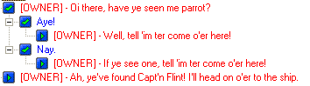

1. Save the conversation as “samwell_convo”. Close the Creature Properties window. Right-click Samwell and update all instances of him.
2. Edit the Captain Flint the parrot’s conversation in the same way as Samwell’s. Create a new conversation node with the text “Pieces of eight! Pieces of eight!” Add a player reply with the text “Oi you, head back to Samwell.” The conversation should look like the screenshot below.



1. Save the conversations as “parrot_convo”. Update all instances of Captain Flint.
2. Add another conversation node to the root node of “captain_convo” with the text “We be ready to leave! Now, where be me crew?” Add a player response, “I’ll go find them!” You do not need to update all instances on the Captain, since the conversation is already linked to all instances of him.
3. Close Aurora and open your story in ScriptEase II.

## Creating a Side Quest:

1. As we said, we do not want to continue the quest from the previous one. Instead, we should create a new Story Point off of the Start Story Point and call it “Parrot Quest”. Choose the Insert Story Point tool and click the Start Point to add another Story Point (Figure 1).

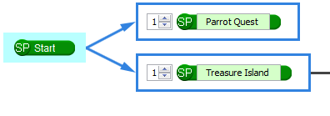

Figure

1. To start, we shouldn’t let the player respond to the parrot before they have met Samwell, since that would not make sense. Add a “When subject is spawned” cause in the Parrot Quest Story Point and drag Captain Flint into the subject slot.
2. Drag a “Disable dialogue line” effect directly into the cause and drag in the “Oi you, head back to Samwell.” Object, found under parrot_convo. Captain Flint is only spawned once, and we want to make sure this event gets fired, so we add it directly to the cause instead of the “Current Active” Yes section (Figure 2). Since we aren’t using the “Current Active?” question, feel free to delete it.

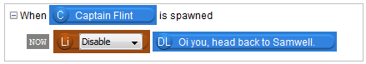

Figure

1. Now we can add a “When subject is reached” cause. Drag the “Oi there, have ye seen me parrot?” dialogue line into the subject slot.
2. Add a “Disable dialogue line” effect into the Yes section with the line “Oi you, head back to Samwell.” This is the line we disabled earlier, but we are enabling it again now, so change the “Disable” slot to “Enable”. Basically it means that after you talked to Samwell, you then have the option to tell the parrot to go back to Samwell.
3. We should also create a side-quest journal record. Create a new Journal Record for Parrot Quest and add a Journal Point for the Record with the text, “One of the pirates told me to find his parrot.” You should also succeed the current Story Point in the same way as always (Figure 3).

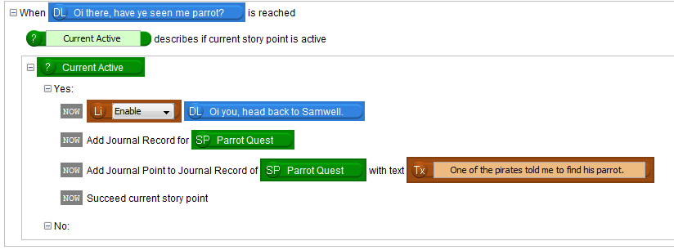

Figure

1. Let’s add another Story Point called “Parrot Found” after “Parrot Quest”. Drag in a “When subject is reached” cause with “Oi you, head back to Samwell.” as subject.
2. In the “Current Active” Yes section of this cause, drag in a “Disable dialogue line” effect. Drag the “Oi there, have ye seen my parrot?” dialogue line into the slot.
3. You should also disable the last conversation node of the Captain at this point, which is “We be ready to leave! Now, where be my crew?” Note that completing this side quest before reaching that point in the main quest will cause this line to never be seen by the player. This is intended, as the captain shouldn’t be telling you to do something you have already done!
4. Add a “Mover walks to Location” effect after this. Drag Captain Flint into the first slot, and create a description for Samwell’s location for the second slot as you have done before. The Location description has to be above the “Mover walks to Location” effect.

Tip:You can rename objects created by descriptions.

Tip:You will notice that this effect has a label called **TODO** on it, whereas the previous ones had **NOW** labels. TODO means that the effect gets added to a game object’s effect queue, while NOW effects occur as soon as the cause occurs. So if the parrot had many effects on its queue, it would finish those before walking to Samwell. Just remember: **TODO effects always happen after all NOW effects, regardless of the order you put them in.**

1. Finally, add another Journal Point to the Parrot Quest Journal Record and succeed this Story Point (Figure 4).

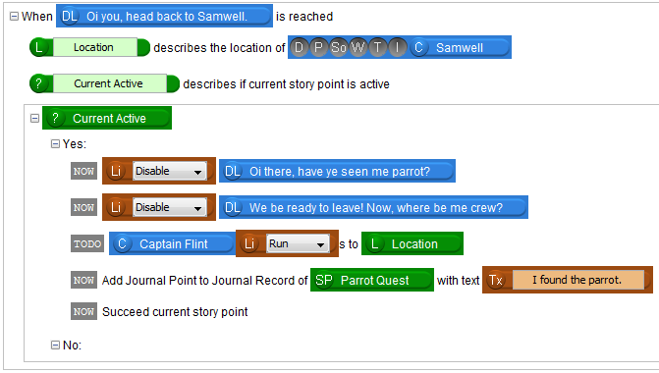

Figure

1. Now that we have reunited the parrot with its owner, we should talk to him again. Add another Story Point called “Parrot Reunited” after “Parrot Found”. Add a “When subject is reached” cause and drag the “Ah, ye’ve found Capt’n Flint! I’ll head on o’er to the ship” dialogue line into it.
2. In the Story Point “Current Active” Yes section, add two “Mover walks to Location” effects to make Captain Flint and Samwell walk to the Location of the ship, which should be described by a Location description as the waypoint “Ship Location” as we did before.
3. Change both instances of “Walk” to “Run”.
4. Also add a Journal Point to both the main story line and the Parrot Quest. Finish the Journal Record of the Parrot Quest and succeed the Parrot Reunited Story Point (Figure 5).

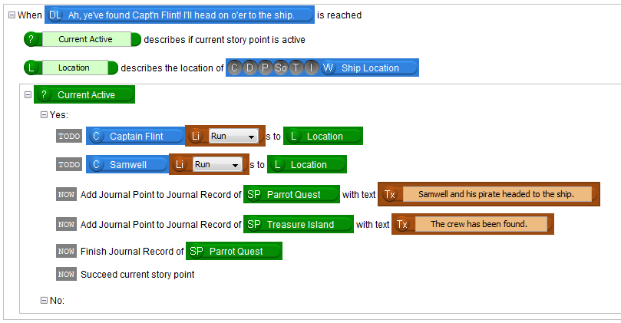

Figure

You have now added a side quest to the game to reunite a parrot and its owner! You have also learned how to use waypoints, and some advanced dialogue line scripting with ScriptEase II.

If you want to take your experience further, try creating your own side quest in the game. This can be anything you want. If you added a pirate by the trees earlier, you could have a quest to bring him a skin of wine.

You may also notice that we still have to speak with Captain Silver before we’re able to start the Treasure Island journal. If you complete the side quest before starting the main quest, you won’t get an update in the main journal. You could try rearranging the story points or experimenting with how a story point succeeds in order to fix this. The parrot might get stuck in the rocks on the way to Samwell. You could try using additional waypoints and triggers to create a path for the parrot to travel in.

Upon reaching these waypoints, the parrot and Samwell both return to their original locations. You could use some descriptions and effects to force them to stay.

In the next tutorial, we will finish the story by tying the two quests together.